Heritage Treasures: An In-Depth Analysis of UNESCO World Heritage Sites in Tableau
REPORT

1. INTRODUCTION
1.1 Project Overview
The UNESCO Heritage Analytics Platform is an interactive data visualization system developed to explore, analyze, and interpret global heritage site data in a meaningful way. The system integrates data analytics, visualization tools, and web technologies to transform static heritage datasets into dynamic dashboards. This allows users to gain insights into cultural, natural, and mixed heritage sites across different countries and regions.
The application provides an intuitive interface that enables users to interact with visual analytics, apply filters, and study trends. By converting complex data into easy-to-understand visuals, the platform enhances accessibility and promotes awareness about heritage conservation.
1.2 Purpose
The primary purpose of this project is to design and develop a centralized digital platform that allows users to explore heritage datasets interactively. The system aims to:
- Provide meaningful visual insights
- Simplify data interpretation
- Support academic research
- Enhance public awareness
- Enable comparative analysis
The platform bridges the gap between raw heritage data and user understanding through modern visualization techniques.
2. IDEATION PHASE
2.1 Problem Statement
Global heritage data is often scattered across multiple sources and presented in non-interactive formats, making analysis difficult. Researchers and users face challenges when trying to interpret patterns, compare countries, or analyze trends over time.
2.2 Empathy Map Canvas
Understanding the end user helped define system requirements:
Users think:
“How can I analyze heritage data easily?”
Users feel:
Confused by complex datasets.
Users see:
Static reports and tables.
Users need:
Interactive dashboards and filters.
2.3 Brainstorming
During brainstorming, multiple solution ideas were evaluated. The selected approach was to create a web-based platform integrated with visualization dashboards because it offered:
- Maximum accessibility
- Real-time interaction
- Scalable design
- Easy usability
3. REQUIREMENT ANALYSIS
3.1 Customer Journey Map
User visits website → explores homepage → opens dashboards → applies filters → analyzes results → gains insights.
The user interaction flow is designed as follows:
- User opens website
- Reads project overview
- Navigates dashboards
- Interacts with filters
- Analyzes data
- Draws insights
This journey ensures a smooth, guided analytical experience.
3.2 Solution Requirement
Functional Requirements
- Display dashboards
- Allow filtering
- Show analytics insights
- Provide navigation
Non-Functional Requirements
- High performance
- Secure embedding
- Responsive design
- Scalability
3.3 Data Flow Diagram
User → Flask Web App → Data Processing → Dataset → Visualization Engine → Dashboard Output.
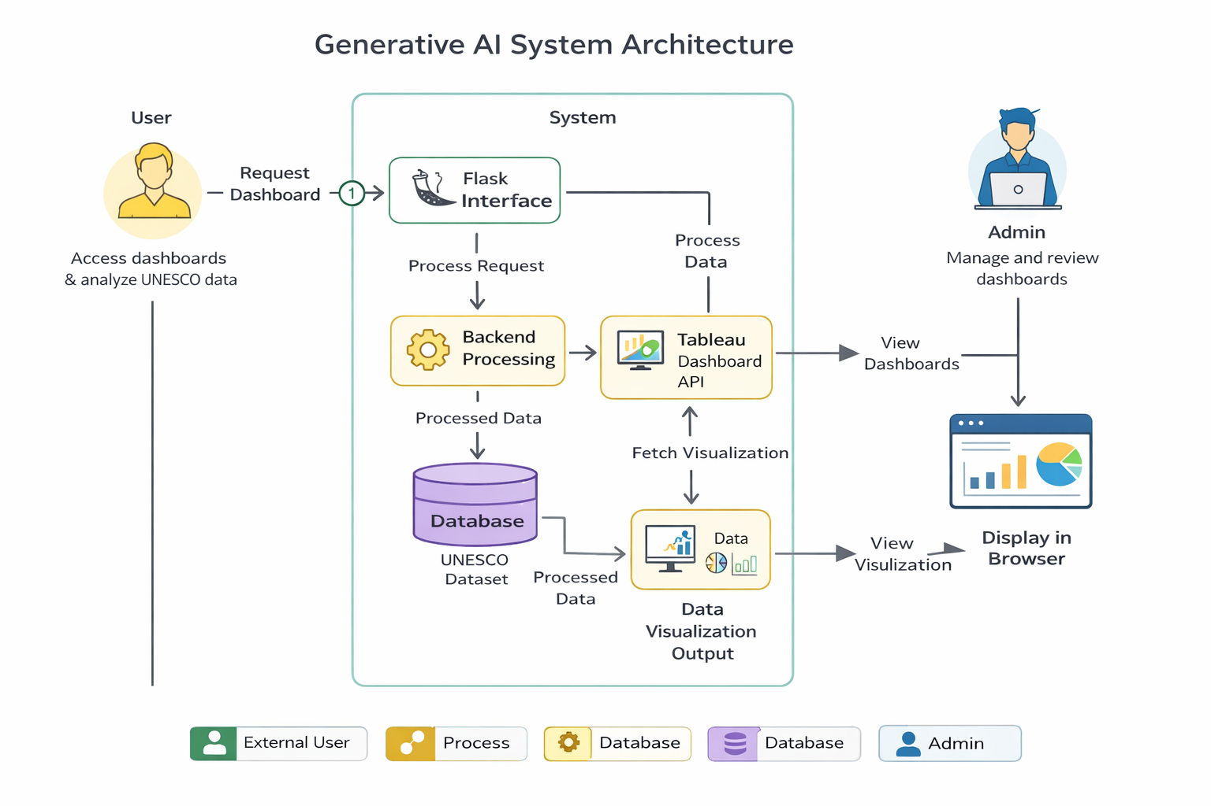
3.4 Technology Stack
Frontend: HTML, CSS, Bootstrap | Backend: Python Flask | Visualization: Tableau | Data: UNESCO Dataset.
LAYER | TECHNOLOGY
Frontend | HTML, CSS, JavaScript
Backend | Python Flask
Visualization | Tableau Public
Data | UNESCO Dataset
Hosting | Localhost Server

4. PROJECT DESIGN
4.1 Problem Solution Fit
Interactive dashboards effectively solve the problem of static data interpretation by providing visual insights.
4.2 Proposed Solution
Develop a web portal that integrates Tableau dashboards within a Flask application styled with a heritage theme.
4.3 Solution Architecture
User Interface → Flask Server → Embedded Tableau Dashboards → Data Source.
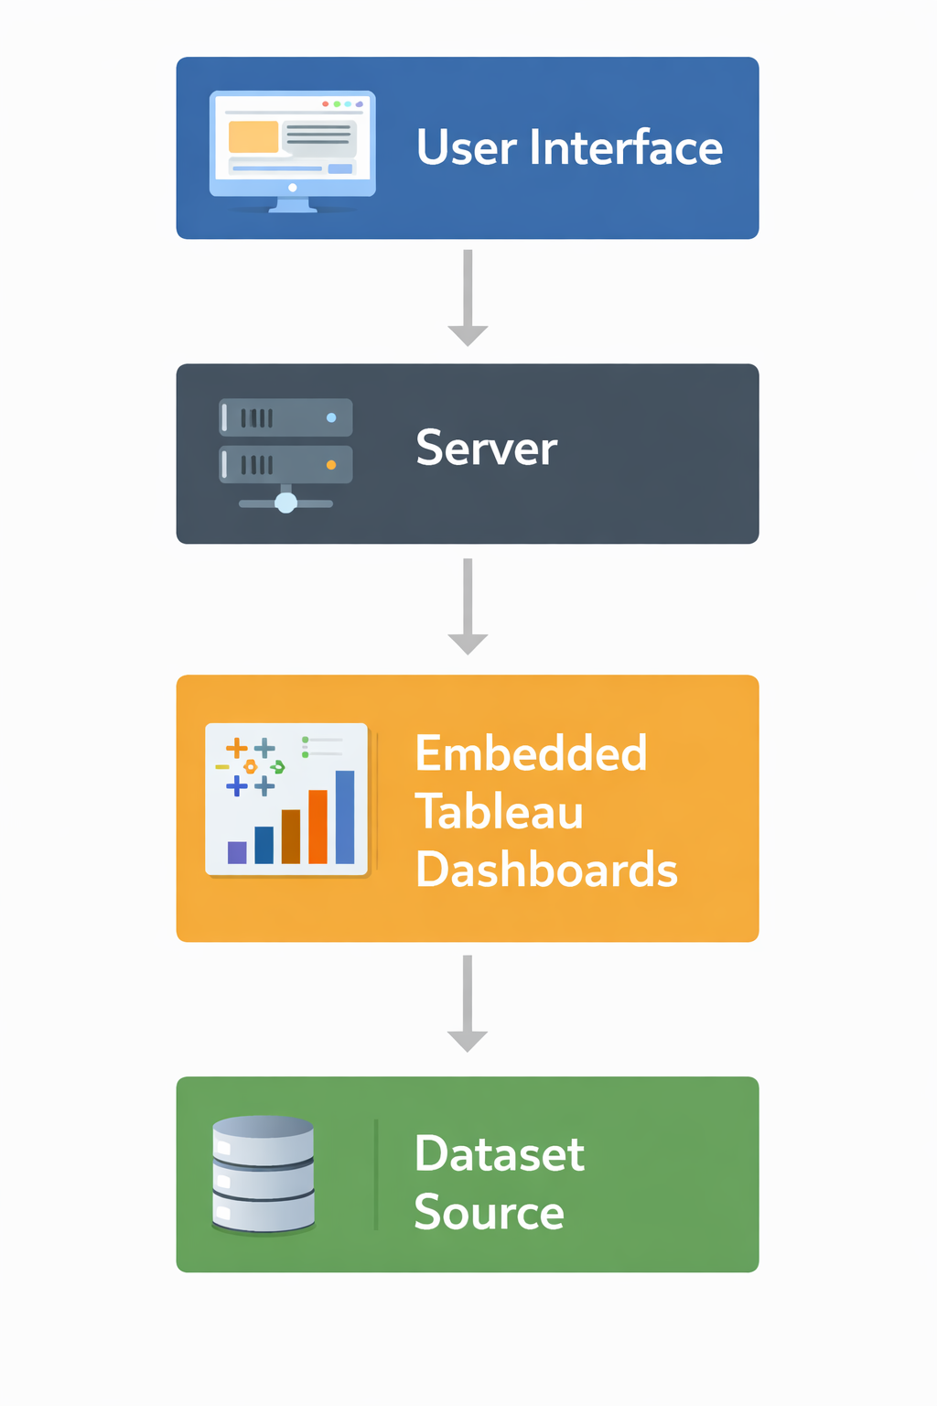
5. PROJECT PLANNING & SCHEDULING
5.1 Project Planning
Phase | Description
Requirement Analysis | Understanding problem
Design | Architecture + UI
Development | Flask + Dashboards
Testing | Performance & usability
Deployment | Server

6. FUNCTIONAL AND PERFORMANCE TESTING
6.1 Performance Testing
Dashboards were tested for load time, filter response, rendering speed, and data accuracy. Performance remained stable under multiple filter conditions.
Performance testing confirmed that:
- Dashboards load efficiently
- Filters respond instantly
- Navigation is smooth
- Visual elements render correctly
The system successfully handled dataset visualization without delays.
7. RESULTS
7.1 Output Screenshots
The system successfully generated interactive dashboards showing site distribution, category analysis, and global trends.
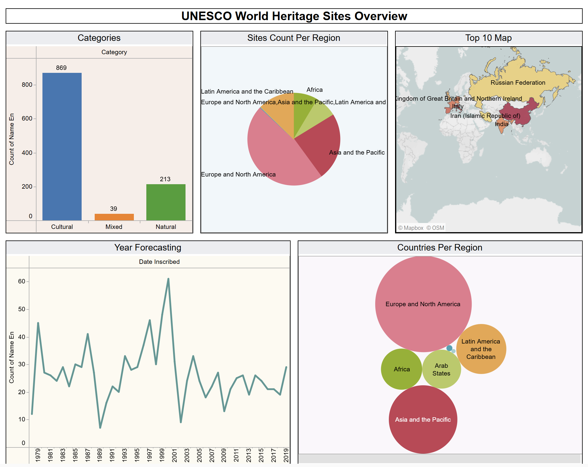
Fig: Dashboard – 1
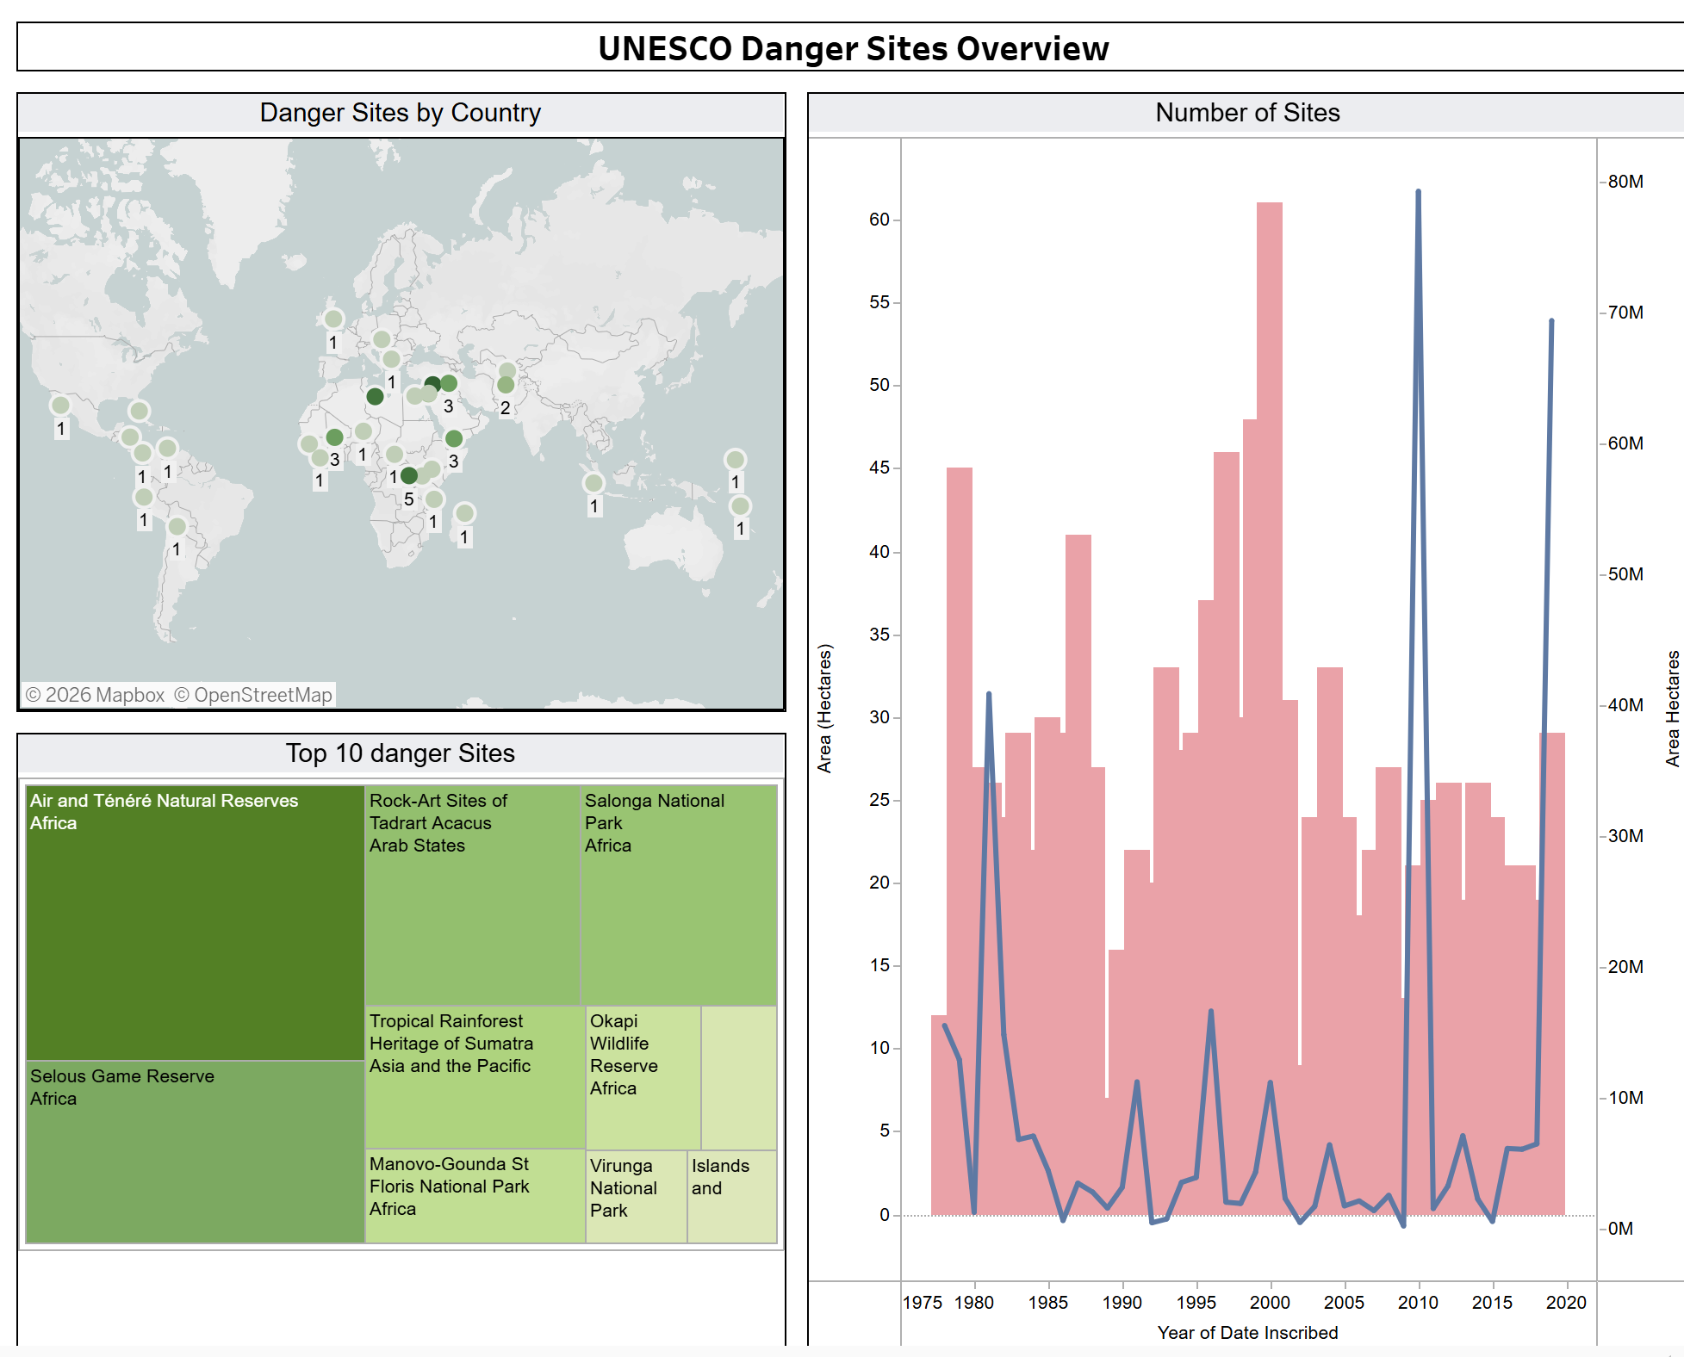
Fig: Dashboard - 2
8. ADVANTAGES & DISADVANTAGES
Advantages
- Interactive analytics
- Easy to understand visuals
- User-friendly interface
- Centralized data platform
Limitations
- Requires internet connection
- Depends on dataset quality
- Limited offline functionality
9. CONCLUSION
The UNESCO Heritage Analytics Platform successfully demonstrates how data visualization can enhance understanding of global heritage information. The project highlights the importance of combining analytical tools with intuitive interfaces to create meaningful user experiences. It provides an efficient method to explore heritage data and supports research, education, and awareness initiatives.
10. FUTURE SCOPE
Future enhancements may include:
- Real-time dataset updates
- AI-based prediction analytics
- Geographic interactive maps
- User login system
- Downloadable reports
- Cloud deployment
These improvements can transform the platform into a large-scale analytics system.

11. APPENDIX
Source Code
import { Landmark, Home, Info, BarChart3, Globe } from "lucide-react";
import heroBg from "@/assets/hero-bg.jpg";

const Index = () => {
const scrollToDashboards = () => {
document.getElementById("dashboards")?.scrollIntoView({ behavior: "smooth" });
};

return (
<div className="min-h-screen bg-background">
{/* Navigation */}
<nav className="nav-dark fixed top-0 left-0 right-0 z-50 flex items-center justify-between px-8 py-3">
<div className="flex items-center gap-2">
<Landmark className="h-6 w-6 ornament" />
<span className="text-xl font-bold gold-text font-['Cinzel']">
UNESCO <span className="font-normal italic font-['Playfair_Display']">Heritage Explorer</span>
</span>
</div>
<div className="hidden md:flex items-center gap-8">
<a href="#" className="flex items-center gap-1.5 text-sm text-[hsl(var(--parchment))] hover:text-[hsl(var(--gold-light))] transition-colors">
<Home className="h-4 w-4" /> Home
</a>
<a href="#about" className="flex items-center gap-1.5 text-sm text-[hsl(var(--parchment))] hover:text-[hsl(var(--gold-light))] transition-colors">
<Info className="h-4 w-4" /> About
</a>
<a href="#dashboards" className="flex items-center gap-1.5 text-sm text-[hsl(var(--parchment))] hover:text-[hsl(var(--gold-light))] transition-colors">
<BarChart3 className="h-4 w-4" /> Dashboards
</a>
<button className="btn-gold flex items-center gap-1.5 px-4 py-2 rounded-lg text-sm">
<Globe className="h-4 w-4" /> Explore World
</button>
</div>
</nav>

{/* Hero Section */}
<section className="relative h-[70vh] flex items-center justify-center overflow-hidden">
<img src={heroBg} alt="Ancient temple" className="absolute inset-0 w-full h-full object-cover" />
<div className="hero-overlay absolute inset-0" />
<div className="relative z-10 text-center px-4">
<h1 className="text-5xl md:text-7xl font-bold text-[hsl(var(--parchment-light))] mb-2">
Discover <span className="italic font-['Playfair_Display'] gold-text">World Heritage</span>
</h1>
<div className="flex items-center justify-center gap-3 my-4">
<span className="w-16 h-px bg-[hsl(var(--gold))]" />
<span className="ornament text-lg">✦</span>
<span className="w-16 h-px bg-[hsl(var(--gold))]" />
</div>
<p className="text-lg md:text-xl text-[hsl(var(--parchment))] font-['Playfair_Display'] italic tracking-wide">
Preserving the Past • Inspiring the Future.
</p>
<button onClick={scrollToDashboards} className="btn-gold mt-8 px-8 py-3 rounded-lg text-base flex items-center gap-2 mx-auto">
<Landmark className="h-5 w-5" /> Explore Dashboards
</button>
</div>
</section>

{/* Dashboards Section */}
<section id="dashboards" className="parchment-bg py-16 px-4">
<div className="max-w-6xl mx-auto">
<h2 className="text-3xl md:text-4xl font-bold text-center text-foreground mb-2">
Interactive Dashboards
</h2>
<div className="flex items-center justify-center gap-3 mb-12">
<span className="w-12 h-px bg-[hsl(var(--gold))]" />
<span className="ornament text-sm">❖</span>
<span className="w-12 h-px bg-[hsl(var(--gold))]" />
</div>

{/* Dashboard 1 */}
<div className="mb-12">
<h3 className="text-xl md:text-2xl font-semibold text-center mb-6">
Overview of <span className="gold-text">UNESCO Sites</span>
</h3>
<div className="dashboard-card p-2 overflow-hidden">
<iframe
src="https://public.tableau.com/views/CharanUnescositesOverview/Dashboard1?:embed=y&:display_count=no&:showVizHome=no"
width="100%"
height="600"
className="rounded"
allowFullScreen
/>
</div>
</div>

{/* Dashboard 2 */}
<div>
<h3 className="text-xl md:text-2xl font-semibold text-center mb-6">
UNESCO <span className="gold-text">Heritage Sites</span> Analysis
</h3>
<div className="dashboard-card p-2 overflow-hidden">
<iframe
src="https://public.tableau.com/views/CharanUnescosites/Dashboard2?:embed=y&:display_count=no&:showVizHome=no"
width="100%"
height="600"
className="rounded"
allowFullScreen
/>
</div>
</div>
</div>
</section>

{/* Footer */}
<footer className="footer-dark py-6 px-8">
<div className="max-w-6xl mx-auto flex flex-col md:flex-row items-center justify-between gap-4">
<p className="text-sm opacity-80">
© 2026 UNESCO Heritage Analytics Project
</p>
<div className="flex items-center gap-4">
<Globe className="h-5 w-5 ornament cursor-pointer hover:opacity-80 transition-opacity" />
</div>
</div>
</footer>
</div>
);
};

export default Index;
Dataset Link
UNESCO official dataset source.
GitHub & Demo Link
Heritage-Treasure-Github

